# CS 340 README Template

## About the Project/Project Title

This project will allow Grazioso Salvare, an international rescue-animal training company, the ability to find eligible dog candidates that they can adopt and provide training to help find and help rescue humans and other animals.

## Motivation

I work for Global Rain and we have been contracted by Grazioso Salvare to create a software application that allows their company to identify and categorize dogs using a database of five animal shelters. This program allows the basic CRUD (Create, Read, Update, and Delete) features in the database.

## Getting Started

*To get a local copy up and running, follow these simple example steps:*

1. Ensure you have MongoDB installed on the device you want to use.
2. Make a database with a name that has meaning.
3. Create a user account that has read and write permissions to that database
4. Import your data to that database
5. Load up mongosh and utilize the database to your liking.
6. Then open up the AnimalShelter.py file and make changes to the __init__ function to match your correct MongoClient database that is being used, along with the username and password.
7. To use the Create, Read, Update, and Delete functions you can change the code in the ipynb file to match what you are wanting to create/read/update/delete.

## Installation

To be able to run this program you will need to install the current versions of Python, MongoDB, and Jupyter Notebook. All of these programs walk you through how to install them, so just go to their corresponding pages on google.

**Why These Tools?**

Python, MongoDB, and Jupyter Notebook are all trusted and well used among the programming world. They have been around for a while and have great support when it comes to their products. This should allow for longevity of this program and the ability to upgrade when the need arises.

**Challenges**

There were many challenges I faced along the way to complete this project. I’ve never coded in HTML before so learning that and MongoDB at the same time was pretty difficult. I ran into many callback errors and non iterable errors. I was able to fix them and get the program to run. One of my major problems was figuring out how to get the table to update when choosing between the selections, I found out that you need to drop the ‘_id’ column every time you call the database again.

## Usage

### Tests – In the following screenshots you will see how you can run the program

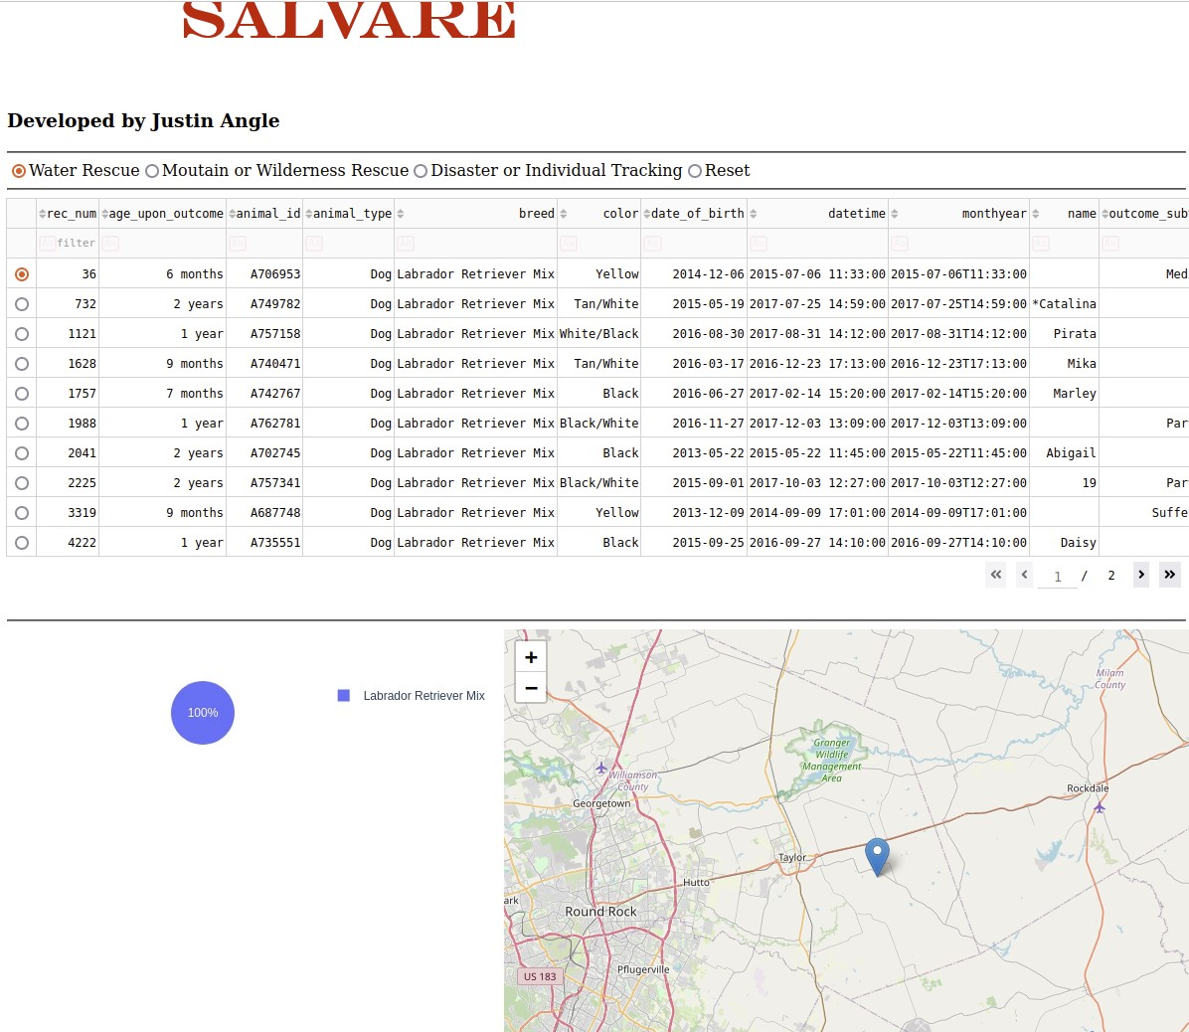

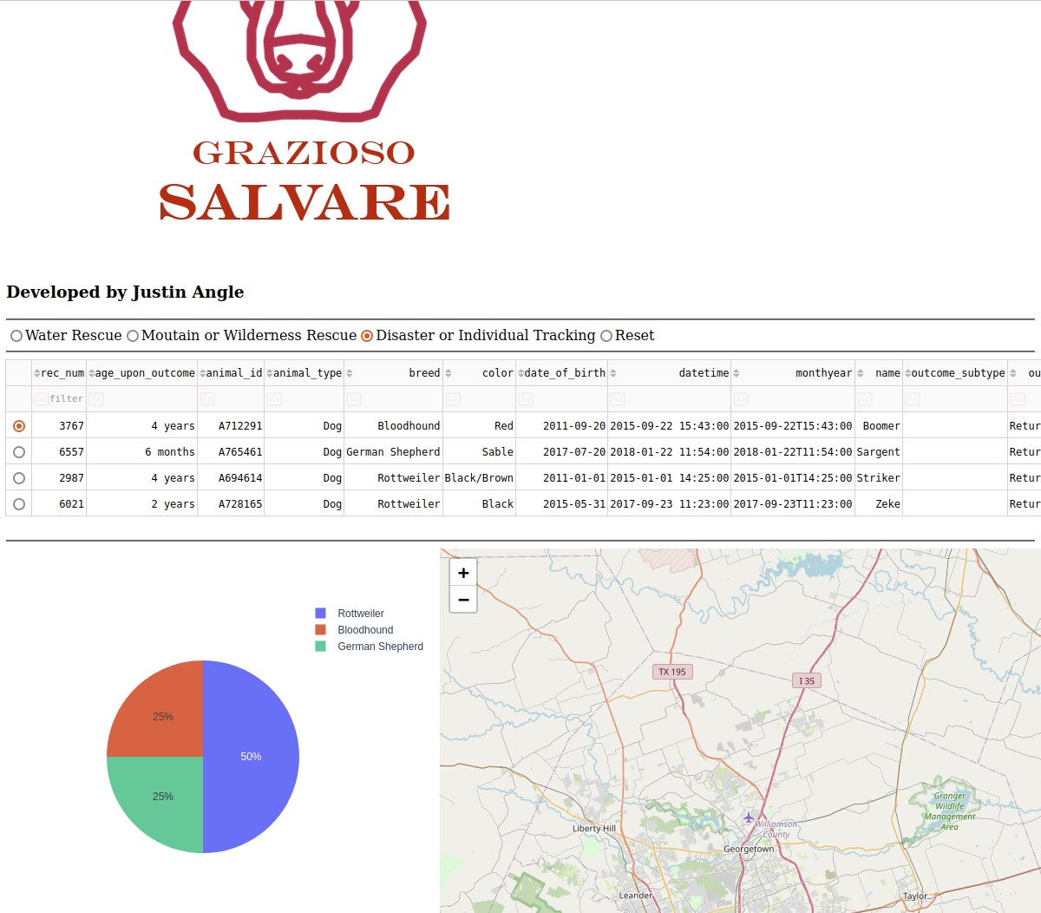

## Contact

Your name: Justin Angle